The data used for study this were collected from the IPUMS database for both 2010 and 2019, the additional gender variable has also been included in the analysis. For the analyses to be comparable the data were required to match the coding and format used by ACFV, this operation was carried out using Python along with Numpy and Pandas.

Firstly, it is important to ensure that the data in the dataset are accurate and free of imputations, such observations were labelled as “allocated” and subsequently dropped from the dataset to prevent any inconsistencies or outliers.

To remain comparative to ACFV, our study continues to use White and African-American men and women only. There were some limitations to using Hispanic individuals which are explained further below. The race variable has been filtered to take on one of the two ethnicities and then subsequently dropped after generating a new variable called “black” which takes on “1” if the individual is black and “0” if the individual is white.

The same principle as above has been applied to the gender variable, by way of creating a male dummy which takes on “1” if the individual is a male and “0” if they are a female.

As income is measured in nominal terms, for comparative purposes the yearly income was transformed into real terms in 1989 prices, by taking the ratios of the personal consumption expenditure index of 1989 and both 2010 and 2019 and multiplying these ratios by the yearly income this acts a deflationary measure and is useful in comparison.

Calculating weekly income had a challenging approach, as the data available was only in yearly wage for the year prior, to make a sound estimate further regarding the number of weeks worked per individual had been used. Taking an average of the weeks worked by an individual and using the ratio of yearly income to average weeks worked provided a more accurate estimate of an individual's weekly income. The average used varies slightly across the range of weeks, for the majority, the midpoint is a sensible estimate, except in the case of those working 50-52 weeks, where 52 weeks were used instead. This follows the logic that those in paid employment for 50-52 weeks are working for the whole 52 weeks, those working 50 or 51 weeks are assumed to account for a smaller proportion of the observed sample. The last step involves taking a natural log transformation of the weekly incomes of the observations.

Education data extracted from PUMS compared to ACFV had significantly different coding, which needed to be adjusted for, using a mapping procedure taken from the supplementary notes to ACFV. For many mappings there were no issues besides the mappings for associate and bachelor's degrees, both of which are represented by 2 values in ACFV, however the PUMS data does not distinguish these and only has one code for associate and bachelors' level of education each. To overcome this, a conservative approach had been taken to use 14 years of schooling for everyone with an associate's degree and 16 years of schooling for those with a bachelor's degree, as opposed to 15 and 17 years, which have been excluded from the mappings. With the education variable available, this allows easy calculation of the experience variable and its square.

The extension of this study has allowed for the comparison of both men and women which differs from ACFV and therefore the data is finally split accordingly into four datasets to represent the year and gender of the individuals.

*(Code is available in appendix)*

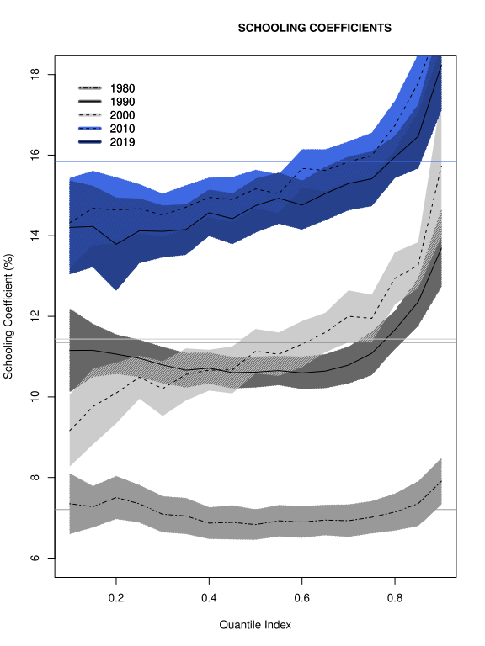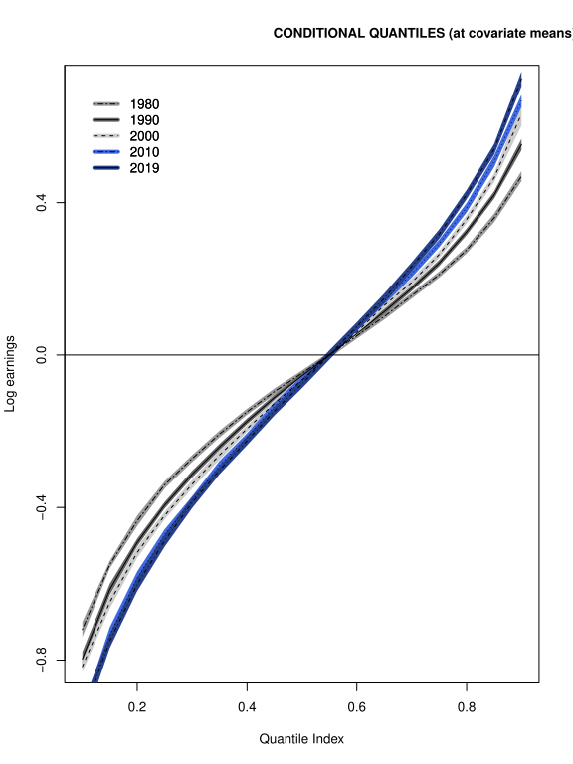

The figures above are an extension to ACFV and in addition to the original years observed, the updated plot shows the impacts of an extra year of schooling across the different quantiles for 2010 and 2019 for men. There is little change from 2010 to 2019, however compared to 2000 the function has flattened out implying that the impact of additional years of schooling is not as strong as it once was, this is in line with recent progressions in career options available that facilitate higher earnings without the need for the highest level of education.

Towards the upper quantiles of earnings, education still plays a vital role, this is a characteristic that is likely to be quite resistant to time as many traditional jobs which pay large salaries are dominated by highly educated individuals, namely those in healthcare, law, engineering and finance. Subsequently they will always p

Another interpretation of the conditional quantile function is the increasing steepness over the years shows that real income has worsened for the lower quantiles, whilst it has improved for the higher quantiles, this is evidence in favour of widening inequality over the last 40 years.

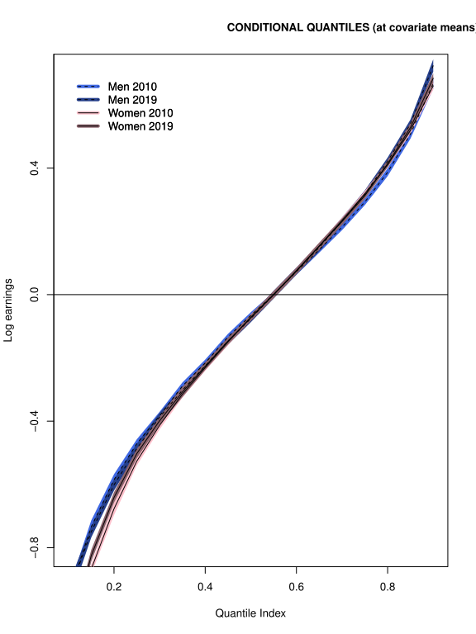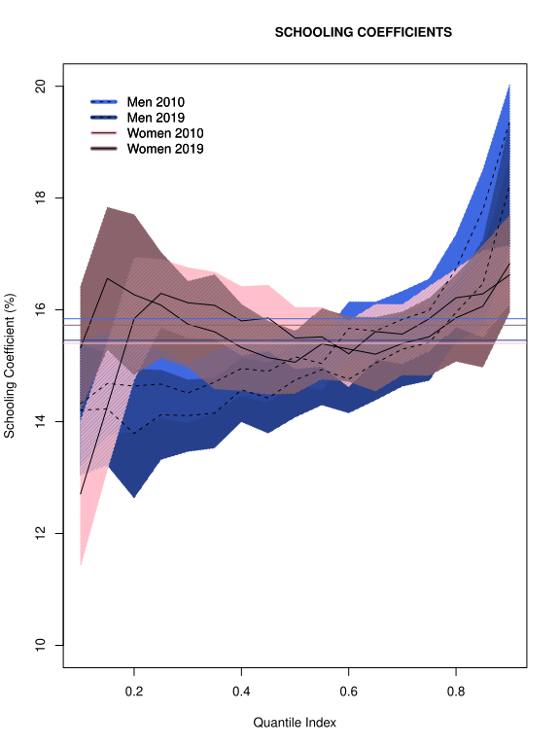

As an addition to ACFV, this study includes women as well as men for 2010 and 2019. The results are interesting in the lower quantiles, it seems that women in these quantiles see a larger variation in their income which is driven by additional years of schooling, this almost the same level of variation seen in the highest quantile, on the other hand there is a slight dip in the median neighbourhood.

Compared to their male counterparts, women around the first quartile, experience a larger variation in income explained by their level of education. Despite this, earnings for women are still lower in general compared to men in the lower quantiles.

On the other hand, towards the top of the CQF, men see the largest variation in income as a result of additional years of schooling, and generally have higher earnings than women in these quantiles.